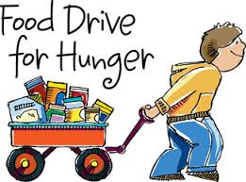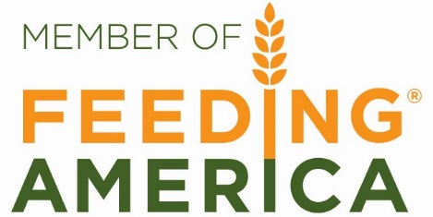

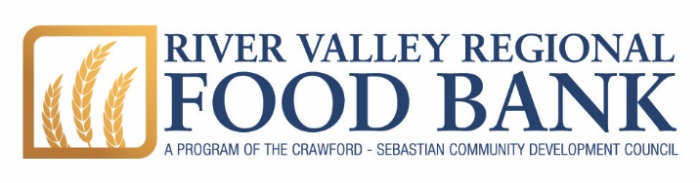

MEMBER AGENCY
HANDBOOK

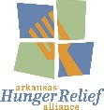
Est. August 1, 2019

MEMBER AGENCY HANDBOOK

Table of Contents

Introduction |  | 2

Membership Agreement Recordkeeping and Reporting Monitoring Visits
3
5
6
7
9
12
13
16
Types and Uses of Products
Product Inventory and Shopping Procedures Fees and Payment Information Food Safety Information Suspension and Termination
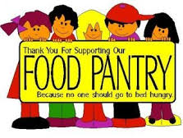

Welcome! | River Valley Regional Food Bank

We are thrilled you are considering becoming a member agency of River Valley Regional Food Bank. We believe that when we are united together to fight hunger our neighbors will be fed and through our partnership we can work to change our communities for the better. While our mission at the Foodbank is to be the foundation in the fight against hunger, we see our agencies as the boots on the ground.

The purpose of River Valley Regional Food Bank is to acquire and distribute, through local and national partnerships, large quantities of food and other resources to feed hungry people. RVRFB is a nonprofit organization that distributes food to food pantries, soup kitchens, and other feeding programs to over 185 nonprofit agencies and churches throughout the River Valley in Arkansas. These partnerships make it possible to get food directly into the hands of the people who need it across 8 Arkansas counties. Member programs include pantries, emergency shelters, soup kitchens, day care centers, low-income senior meal programs, and multi-service neighborhood programs and shelters.
2
River Valley Regional Food Bank is a founding member of Arkansas Hunger Relief Alliance. Through the Alliance, RVRFB and other members work together to increase food donations, collect information about the needs of hungry Arkansans and how these needs are being met, and raise funds and other resources to support the work of six hunger relief partners in Arkansas and their member agencies.
In order to be a member agency of River Valley Regional Food Bank, your organization must be an established nonprofit as defined by the Internal Revenue Service. This means your organization must be designated by the IRS as a 501(c)(3) tax-exempt organization, be wholly owned by an organization with this designation, be sponsored by a 501(c)(3) organization, or qualify for the IRS equivalent for religious organizations. Non 501(c)(3) religious organizations must meet nine (9) of the 14 IRS eligibility requirements. A form describing these requirements is included in this packet.
Please take the time to carefully read the information in this packet and follow the instructions provided.
RVRFB has a wonderful team of talented staff who are available to assist you in your efforts to help feed your community. If you have questions about meeting the nonprofit requirement or about the application process, please contact our Agency Relations Director t 479-785-0582.
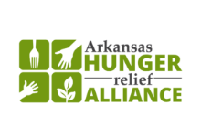
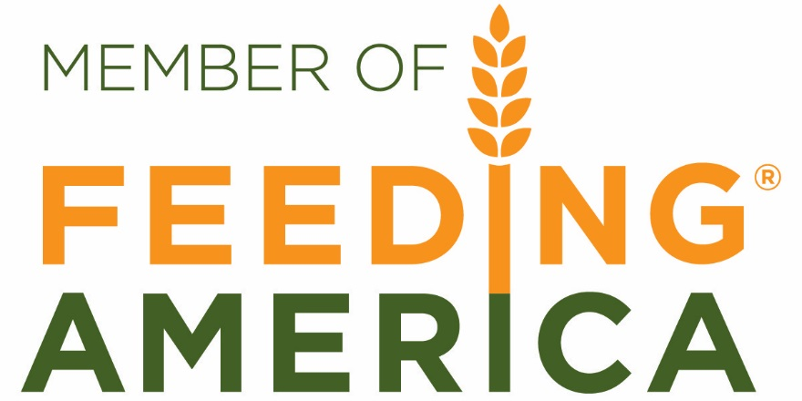
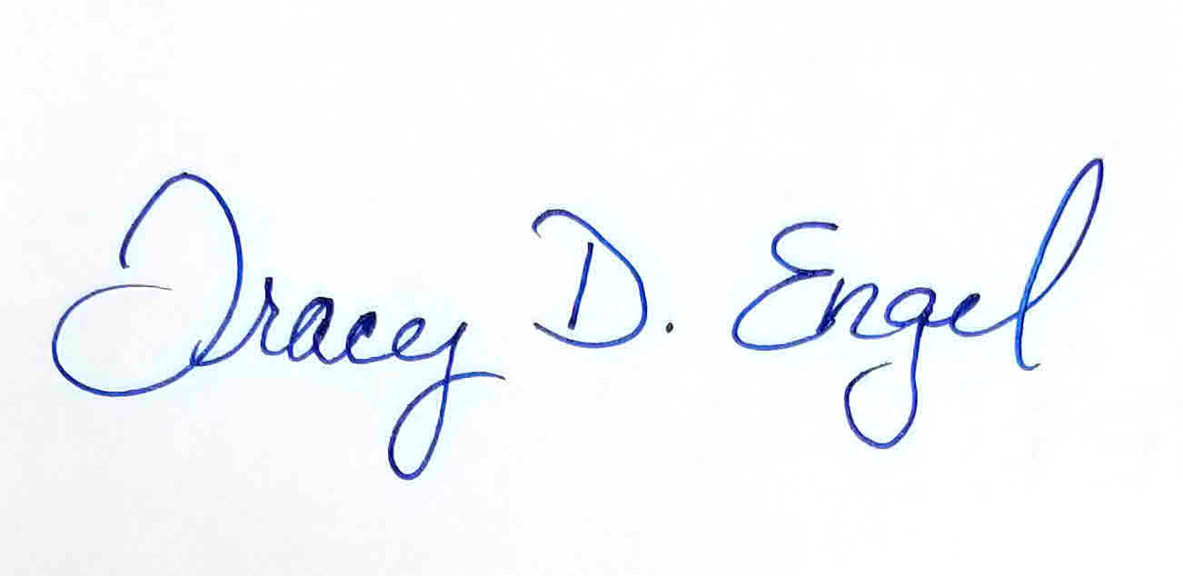
Tracy D. Engel
Director
River Valley Regional Food Bank
Thank you for your partnership,

RIVER VALLEY REGIONAL FOOD BANK MEMBERSHIP AGREEMENT
3
The following criteria must be agreed to and complied with for your agency to become and remain a member in good standing of River Valley Regional Food Bank (RVRFB). An official representative of your agency is required to complete and sign this agreement annually signifying that the following criteria are understood and will be faithfully met. Placing a check mark by the item indicates that you understand and agree to comply with the criteria. If the item does not apply to your organization, indicate this by putting N/A in the space beside it.
Our organization qualifies under section 501(c)(3) of the Internal Revenue Service code or meets the definitional requirements of the IRS code to qualify as a church.
In operating our food program, we agree that we will:
Not discriminate in the provision of service, against any person because of race, color, citizenship,
religion, gender, national origin, ancestry, age, marital status, disability, sexual orientation including gender identity or expression, unfavorable discharge from the military or status as a protected veteran.
Never charge clients for food or require clients to pray, donate, or work to eat or receive products.
Not sell, transfer, barter, nor offer for sale, the items supplied by RVRFB in exchange for money, property, goods, or services, or otherwise allow items to re-enter commercial channels, and will not use donated products for fundraising.
Use all items drawn from RVRFB only in activities included in the member’s tax-exempt purposes and
solely for feeding people who are ill, in need, or infants.
Abide by the RVRFB’s policies, procedures and record keeping requirements.
Safely and properly handle donated product in accordance with all local, state and federal regulations,
including appropriate transportation of all product. This includes covering with a tarp any food transported in open pickup trucks or trailers.
Ensure that at least one person on staff has successfully completed a food safety course. (If meals are
prepared and served on site, at least one staff member must commercial food safety certification.) Accept food in “as is” condition. Certifications copy must be turned into the RVRFB.
Follow RVRFB recall guidelines.
Notify RVRFB when any claim of liability with respect to food is received.
Discard any unfit food received from RVRFB, and immediately notify RVRFB staff.
Allow regular monitoring by RVRFB representatives to verify compliance with these criteria and the
information provided on the agency’s application and monthly reports.
_____________ agrees to adhere to the following membership criteria.

RIVER VALLEY REGIONAL FOOD BANK MEMBERSHIP AGREEMENT
4
Support the operation of RVRFB by paying a handling fee on a per pound basis for applicable products.
Pay an annual membership fee of $50.00 or $75.00, if more than one site.
Accept that the original donor, RVRFB and Feeding America offer no express warranties in relation to the
product.
Hold harmless from any claims or obligations in regard to your organization or the donated product,
_______ Release the original donor, RVRFB and Feeding America from any liabilities resulting from the donated
product.
_______ Adhere to any use of product restrictions placed on items by the RVRFB and any additional donor
stipulations.
Submit by the 1st of each month a report on the previous month’s service activity.
Order from RVRFB a minimum of six times per year, unless special arrangements have been made with RVRFB staff.
_____ Hold regular distributions at least once a week display distribution dates and times outside the

the original donor, RVRFB and Feeding America.

pantry, and notify RVRFB immediately of any changes in distribution dates and times.

_____ The agency as well as the River Valley Food Bank, will be required to uphold a positive, mutual respect of
each entity, Any negativity can be grounds for terminating membership.

River Valley Regional Food Bank Representative Signature Agency Representative Signature

Please Print Name Please Print Name

Date Date

Recordkeeping and Reporting
5
Recordkeeping
All member agencies must keep a copy of the following on hand at all times:
- Membership Agreement between your agency and the River Valley Regional Food Bank
- Membership Application, including all attachments
- Member Agency Handbook
- Paperwork indicating non-profit or church designation status
- Annual pest inspection reports
- Health inspection licenses, if applicable
- Member certification for required trainings
The following information must be collected and records maintained for at least one year. These documents will be examined during monitoring visits.
- Documents of transactions between your agency and the River Valley Regional Food Bank
- Monthly and inventory reports
- Documents of transactions with USDA, if applicable
- A documented method for non-discriminatory distribution to people in need
- Documentation on River Valley Regional Food Bank products used for the maintenance of your program, including list of products, amounts used, and how used
- Any and all donations received, other than from the RVRFB
For assistance in developing a method of counting and recordkeeping, please contact the RVRFB Agency Relations Director at 479-434-2873.
Reporting
Agencies are responsible for submitting a Monthly Report even if no orders were placed or received during any given month. A sample of this report is included in your Orientation Packet. The report is due the 1st of each month and covers the previous calendar month. For example, the report for January is due by February 1.
The monthly report has a place to report any changes in the following:
- authorized personnel - mailing address
- contact person’s name - phone numbers
- storage or distribution location - days and hours of operation
- equipment changes - services and/or programs
These reports are very important to the Foodbank’s ability to accurately report people and families served. Failure to complete and submit the reports will affect your membership with the River Valley Regional Food Bank. Submitting reports each month is a requirement to shop at the Foodbank. Makeup reports i.e. sending in six months of reports in order to meet grant application requirements, is not acceptable.

Monitoring Visits
6
The safety of the products we distribute and efficient and respectful service to those we serve
are of utmost importance to Feeding America and the Arkansas Hunger Relief Alliance. As such, the River Valley Regional Food Bank is required to monitor member agencies every 12 to 18 months to ensure compliance with all membership requirements. The Foodbank’s goal is to conduct annual monitoring visits. This inspection has a two-fold purpose: to provide an opportunity for interaction at your agency instead of at the River Valley Regional Food Bank, and to identify any potential problems and assist in solving them. The visit also enables the River Valley Regional Food Bank staff to assure donors that we have a sound system of protecting, accounting for, and distributing their donated products. The monitoring visit is also the time to renew your Memorandum of Agreement.
The process for a monitoring visit is the membership month of your agency anniversary date you will be sent an email requesting a date and time for an inspection. If there is no response to the email a follow-up phone call will be made to request a date and time for the inspection. If there is no response by the end of the month, your agency will be made inactive until the inspection is completed.
Your agency’s practices regarding the hunger relief services you provide will be reviewed during the monitoring visit. Other items that will be checked include:
- Sanitizing processes
- The cleanliness of the areas where food is stored and handled
- The cleanliness of all appliances and equipment involved
- The availability and condition of hand washing stations and restrooms
- Records described in Section II of this handbook
- Storage and garbage disposal to ensure standards are being met
- Pest control
- Temperature control in storage areas
- Refrigerators and freezers
- Vehicles used to transport food and grocery products
- Customer service standards
- Exit signs and fire extinguishers must be in place
A sample Monitoring Report is included in your Orientation Packet.
Once the report is completed, a representative from your agency will be asked to review and sign the report. A copy of the completed and signed report will be provided to your agency.
Feedback from our agencies is also very important to us, so we sincerely appreciate all of your suggestions, needs, or concerns, whether during this monitoring visit or throughout the year.

Types and Uses of Products
7
Types of Products
A variety of food and non-food products is available through the River Valley Regional Food Bank, including fresh and frozen foods, canned goods, paper products, cereal, beverages, cleaning supplies, and USDA commodities. Availability depends on what is donated or otherwise procured; therefore, inventory may vary greatly from week to week.
If you have questions about what is available at the River Valley Regional Food Bank and how your program might be supported, please contact the RVRFB’s Agency Relations Director at 479-434-2873.
Donated Food: Donated food may be ordered by all member agencies. There is no cost for the products, however, a handling fee of 19 cents per pound is charged. This fee helps to cover the costs of collecting, sorting, storing, and distributing donated products to member agencies. This is not a charge for the product.
Purchased Food: The River Valley Regional Food Bank often supplements the RVRFB inventory by purchasing high quality food at reduced rates. Our goal is to insure that the items RVRFB members depend upon are always available at lower than regular market prices.
USDA Commodities: Eligibility for distribution of USDA commodities is by contract only. Once approved to receive USDA commodities, an agency must comply with all regulations set forth by the Arkansas Department of Health and Human Services. Commodities are free of charge.
Agencies ineligible to receive USDA commodities are:

- Snack only programs
- Institutions of learning, schools, and day care centers
- Agencies that participate in the Parent/Child Nutrition program
- Boy and Girl Scout organizations.
- Any organization that does not have a 501(c)(3) from the IRS
For more information about the TEFAP Program, contact the RVRFB Agency Relations Director at 479-434-2873.
A $10 fee will be charged to any member that fails to keep an order pick up appointment at the River Valley Regional Food Bank warehouse in Fort Smith and does not call 24 hours before the appointment to cancel.

Uses of Products
8
River Valley Regional Food Bank products may be used to feed on-site feeding facility employees or volunteers only when meals are primarily prepared for people in need. No products may be ordered solely for the employees and volunteers, and all food ordered must be appropriate for the ages and needs of the people served. Agencies may use cleaning and paper products from the Foodbank for the up-keep of the facilities in which the feeding programs are located.
River Valley Regional Food Bank products can never be:

- Sold, bartered, or traded
- Used as compensation or gifts for volunteers or employees
- Used at an agency function or party (unless it primarily benefits needy clients)
- Used at church suppers, board meetings, fundraisers, or any events that are not to feed people in need
- Used for any purpose other than to further an agency’s services to people in need

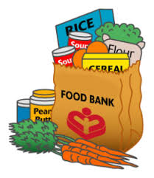
Product Inventory and Shopping Procedures
Before Getting Products from the River Valley Regional Food Bank:
Each agency must have on record at the River Valley Regional Food Bank a list of people authorized to select products at the River Valley Regional Food Bank. (See form attachments.) Keeping this information accurate and up-to-date is important to ensure that your agency is always able to select and receive products from the Foodbank.
Follow These Steps

Make an appointment to pick up your order, or check the delivery schedule that is emailed to those who receive deliveries.

Pick up at Fort Smith Warehouse – Call 479-785-0582, ext. 1 to make an appointment. Appointments are made at 30 minute intervals from 7 am to 11:30 am and from 12:30 pm to 4 pm. The last appointment for the day is at 4 pm.
1

9
If your order is delivered to you, you will receive a delivery schedule the first of each month via email. Please check the schedule for the day your order will be delivered. If your agency’s name is not listed, please call the RVRFB Program Service Assistant at 479-785-0582. Deliveries are scheduled according to the availability of River Valley Regional Food Bank trucks and drivers.

Complete the Inventory (Shopping) List
2

Please read the shopping list carefully and pay close attention to sizes and fees. How to complete the shopping list is covered extensively in new member/new shopper orientation sessions. If you have questions about completing the shopping list, please contact RVRFB’s Agency Relations Director.

Product Inventory and Shopping Procedures

If your order is delivered, your completed order must be submitted at least 48 hours prior to the scheduled delivery.
If you pick up your order at the Fort Smith Warehouse, your completed shopping order must be submitted at least 24 hours prior to your pick up appointment
3
Pick Up Your Order or Meet the Delivery Truck

The following guidelines have been developed by the staff of the River Valley Regional Food Bank to help make your shopping experience as pleasant and efficient as possible. Please read this list carefully.

10
If you pick up your order at the Fort Smith Warehouse:
- Please be on time for your appointment. If you are going to be late, call 479-785-0582 ext. 1. The appointment schedule is full almost every day. If at all possible, you will be accommodated by working your pick up into the schedule that day. If this is not possible, you will be asked to reschedule your appointment. If you do not call and do not show up for your appointment, your agency will be charged a $10 fee.
- Agency shoppers MUST check in at the warehouse desk by loading dock.
- Agency representatives are not allowed in the warehouse unless accompanied by a Warehouse staff member. This is to ensure your safety since forklifts are always in
motion throughout the warehouse.
- You are responsible for loading your own vehicle. When time permits, assistance may be available. Please request assistance, if needed. May request help ahead of time/when appointment is made.
- Before you leave, you are responsible for making sure that all products ordered are received. You have one business day to contact a staff member from RVRFB to report missing product, no exceptions.
- Since most products are donated, they are distributed “AS IS.” No refunds or exchanges.
- Shopping is complete when your list is called in to the office manager. Please do not get additional items.
- Any item food or non-food items requested by shoppers that is pulled then shopper decides not to get item will pay a 10% restocking fee.

Product Inventory and Shopping Procedures
If your order is delivered:

- Please provide a telephone number at which you can be reached AND the street address for your agency.
- Please be available to meet the truck. The Foodbank’s delivery schedule is very tight, and in order to accommodate you and everyone else on the schedule the drivers need to be sure of the location and that someone will meet them when they arrive.

4

Paying for your Order

Your order must be paid for 30 days from the invoice date. Payment can only be by agency check; personal checks or cash are not accepted.

11
Account balances over 90 days past due could be suspended from shopping at the RVRFB until balance is paid in full.
We appreciate your cooperation in helping us serve all agencies in a timely and efficient manner. If you have any questions, comments, or suggestions about shopping at the River Valley Regional Food Bank, please contact the RVRFB Agency Relations Director at 479-434-2873.

Fees and Payment Information
12
Fees
Each member agency is required to pay an annual membership fee and may be required to pay handling, delivery or other fees.
Membership
The annual membership fee is $50 for organizations with one site and $75 for members with more than one site. Membership is due by December 31st annually.
These fees help cover the costs of membership services, including educational opportunities, monitoring, mini-grants, and other costs associated with meeting Feeding America standards of safe food handling.
Handling
The handling fee ($0.19 cents per pound) is an apportioned assessment of member agencies that helps cover the costs of collecting, sorting, storing, and distributing donated products to member agencies. This is not a charge for the products.
Missed Pick Up Appointments at the Fort Smith Warehouse
A $10 fee will be charged to any member that fails to keep an order pick up appointment at the River Valley Regional Food Bank warehouse in Fort Smith and does not call 24 hours before the appointment to cancel.
Payment Information
All fees and invoices must be paid with a check from your agency. Personal checks and cash are not accepted.
Fees are due 30 days from invoice date. An invoice is past due after 30 days and after 90 days renders the agency subject to suspension of membership until payment is received or arrangements for payment are made. Agency account whose balance becomes past due more than 4 times a year will be summited for review to be placed on pay at pick up.
If your agency is experiencing difficulty with payment, an agency representative should contact the River Valley Regional Food Bank Finance Department immediately at 479-785-2303 ext. 114.
Debtors are subject to payment plans or suspension. The agency may ask to be removed from the payment plan once the balance is paid. At the discretion of the River Valley Regional Food Bank, an agency may remain on a payment plan indefinitely. Failure to adhere to the payment plan may be cause for suspension. In the event of perceived discrimination regarding repayment, an agency may appeal the payment plan or suspension before the Executive Director, Tracy Engel.

Food Safety Information
Please follow these guidelines for any products that are of questionable quality. Discard all products with any of the following package conditions, see list below.
FOR CANS:

- rust that cannot be buffed off
- rust around the rim
- a dent that comes to a point or sharp crease
- a dent on the seam of the can
- a dent of the rim of the can
- “puffed” cans where internal pressure has deformed the cans
- products with no labeling
FOR BAGS AND BOXES:
- any signs of infestation or contamination
- any puncture or tear that has broken the innermost seal
- any exposed items that have been taped or repackaged into a bag or box
- products with no labeling
FOR JARS AND BOTTLES:
- any containers that have been opened or if the protective seal is broken
- any sign of contamination or grime around the rim
- products with no labeling
FOR NON-FOOD ITEMS:
- personal care items that are taped or resealed
- items with missing manufacturer’s seals broken or missing
- cleaners and paper goods that are taped or resealed with visible contamination
13

Food Safety Information
Shelf-Life Determination Table
Rules of Thumb for Products That Have Passed “Use By” Date*

Item  Low acid jars and bottles | Time Past “Use By” Date  6 months
High acid jars and bottles | 1 year
Canned goods | 2 years
Sealed dry goods (beans, rice, pasta, etc.) | 1 year
Candy, cakes and cookies | 6 months
Crackers and cereals | 1 year
Fresh bread and rolls | 2 weeks
Refrigerated dairy products | 3 weeks
Refrigerated juices | 4 weeks
Frozen baked goods | 3 months
Frozen pasta and dough | 6 months
Frozen vegetables | 6 months
Frozen meat | 1 year
*Based on information from “The Food Keeper – A Consumer Guide to Food Quality & Safe Handling.” To download a copy, please
visit the Arkansas Hunger Alliance Relief website at www.ARhungeralliance.org or call 501.399.9999 for more information.
Storage Requirements
The following storage requirements must be strictly adhered to in order to maintain product quality and safety. Each of the following items will be examined during a monitoring visit.
The food storage facility should be temperature controlled with adequate ventilation.
- The structure should be secure, with locks in good working order.
- Pest control inspection, and treatment if necessary, should be performed regularly. Where evidence of infestation occurs, a commercial pest control company must be engaged.
- Storage space is adequate.
- Inventory is rotated.
FOR DRY STORAGE:
1. All food is stored off the floor. If supply exceeds shelving space, excess can be stored on pallets, but
must be at least one (1) inch from all walls and four (4) inches off the floor. 14

Food Safety Information
- All containers are properly sealed.
- No food is stored in bathrooms.
- Thermometers must be present in all dry storage areas.
- All non-food products must be stored separately from food products. At a minimum, all non-food products should be stored on lower shelves and never above food products.
FOR REFRIGERATED AND FROZEN STORAGE:
- Refrigerators should be maintained at temperatures not exceeding 40 degrees Fahrenheit.
- Freezers should be maintained at temperatures below freezing, from 0 (zero) degrees to -10 degrees Fahrenheit.
- Thermometers should be present in all refrigerators and freezers.
- All refrigerators and freezers should be defrosted and cleaned with a USDA-approved disinfectant at least two times per year, or as needed.
Recommended storage temperatures (Fahrenheit)
Item  Produce | Storage Temperature  40 degrees or below
Dairy, Eggs | 40 degrees or below
Meat and Poultry | 36 degrees or below
Seafood | 32 degrees or below
Bakery | 70 degrees or below
Candy | 70 degrees or below
Storage Requirements
Product received from the River Valley Regional Food Bank is received in “as is” condition. It is the agency’s responsibility to inspect product at the time of pick up or delivery, whichever is the case. At that time, notify the warehouse personnel if you think something you have received is unusable.
If you encounter unusable product during distribution to your clients, contact the River Valley Regional Food Bank immediately and speak to the River Valley Regional Food Bank Operations Manager. Based on the information you provide, you will receive instructions for use or disposal of the product in question. Please have the following information available when you call:
- Type of product as it is listed on your order form or invoice.
- Date product received from the River Valley Regional Food Bank as listed on the order form/invoice.
- Code dates from the product itself.
- Reasons you question the product. 15

Suspension and Termination
16
Our member agencies are the cornerstone of direct service to those in need in our state, thus, we strive for service excellence and harmony in achieving our mission. However, situations do occur that require evaluation, investigation, and action. We will attempt in every way to work with an agency that falls into non-compliance of standards and will do so in an amicable and professional manner, including utilizing the services of the Arkansas Hunger Relief Alliance to resolve concerns that cannot be resolved by the agency and the Foodbank. Although this type of communication and resolution is preferred, there are guidelines and obligations that, if breached, are cause for suspension or loss of membership.
The following are violations that will result in the suspension or termination of your River Valley Regional Food Bank membership. Please make sure everyone in your agency is aware of these violations.
- Providing false information on your agency’s membership application or monthly reports.
- Failure to comply with any of the membership criteria.
- Exchanging River Valley Regional Food Bank products for money, property, services, or other products.
- Storing River Valley Regional Food Bank products in a residence or unapproved facility.
- Taking River Valley Regional Food Bank products for your own personal use.
- Using River Valley Regional Food Bank products in any manner not related to the tax-exempt purposes of the program.
- Stockpiling River Valley Regional Food Bank products in amounts not commensurate with your level of distribution.
- Transporting, refrigerating, or storing River Valley Regional Food Bank products improperly.
- Violating any federal, state, or local statute, ordinance, code, regulation, or law.
- Breaking the agreement between your agency and the River Valley Regional Food Bank.
- Failing to pay fees and invoices in a timely manner.
- Failure to complete required safe food handling training.
An agency may be suspended from participation in River Valley Regional Food Bank programs if found to be in violation of any of the above. Suspension may be 30, 60, or 90 days in duration. Suspension may completely exclude the member agency from accessing supplies or may limit the types and amounts of supplies that the affected agency may access. A suspended agency will be notified in writing of the reasons for suspension, and the details of how the agency may successfully restore their agency status.
An agency’s membership in the River Valley Regional Food Bank may be terminated if the agency is found to be in violation of any of the above. An agency so affected will be notified in writing of the reasons for termination. The agency will not be eligible for membership reinstatement.
If representatives of a suspended or terminated agency believe the agency has been unjustly treated, they may appeal the decision to the River Valley Regional Food Bank Executive Director. If the issue is not resolved to the satisfaction of the agency, a written review request may be submitted to the RVRFB Executive Director to review appeals within ten (10) working days of the date of the notice of suspension or termination. If a terminated agency’s circumstances change, the agency may re-apply for membership. Please contact the Director of Agency Relations at 479-434-2873, with any questions about this process.

Suspension and Termination
17
Cancellation of Membership by Agency
Agencies may terminate Foodbank membership by writing a letter with a 30 days advance notice to the Foodbank, Attn: Agency Relations Director stating the reason(s) for cancelling membership. In addition:
- Please submit your monthly report for the last month of activity with the Foodbank, including a report for USDA commodities distribution, if applicable.
- Pay all outstanding invoices.
- The disposition of any equipment received from the River Valley Regional Food Bank will be determined on a case-by-case basis.

Agency Representative(s) are/will be held responsible for any and all unpaid invoices, by signing this agreement you are agreeing to take full responsibility of any and all debt owe to the RVRFB. Membership will remain open until all steps stated above are completed, additional fees for unpaid invoices could/will be applied to account balances monthly until debt is paid in full. Accounts left unpaid to lead to farther necessary actions for collecting debt owed, such as but not limited to, reporting debt to credit bureau(s), turning debt over to collection companies, legal action.

Pantry Director Signature Secondary Representative Signature

Please Print Name Please Print Name

Date Date

